Change in Parameters
Single Break:
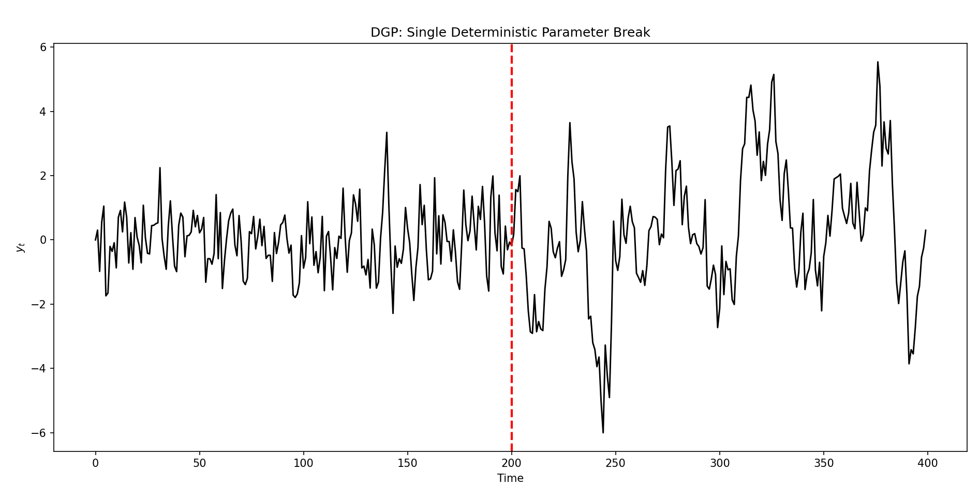
Data-Generating Process: Single Deterministic Parameter Break.
The figure illustrates a realization of an AR(1) process with a single deterministic break in the autoregressive parameter at time $T_{b}=200$. Prior to the break, the process exhibits low persistence, resulting in relatively short-lived fluctuations around the mean. After the break, persistence increases sharply, generating more prolonged deviations and higher volatility clustering. Although the innovation variance remains constant, the increase in persistence amplifies the magnitude and duration of shocks, leading to visibly larger swings in the series. This design isolates parameter instability as the sole source of structural change, providing a controlled environment to evaluate how forecasting models respond when persistence shifts abruptly and permanently.

RMSE across Innovation Distributions and Forecasting Models (Single Break).
The figure reports root mean squared forecast errors for Global AR, Rolling AR, and Markov-switching AR models under Gaussian and mildly heavy-tailed Student-t innovations. Across all innovation distributions, RMSE increases as tail thickness rises, reflecting higher forecast uncertainty induced by larger shocks. This increase is most pronounced for the Global AR model, which is least adaptive to structural change and therefore most sensitive to deviations from Gaussianity.
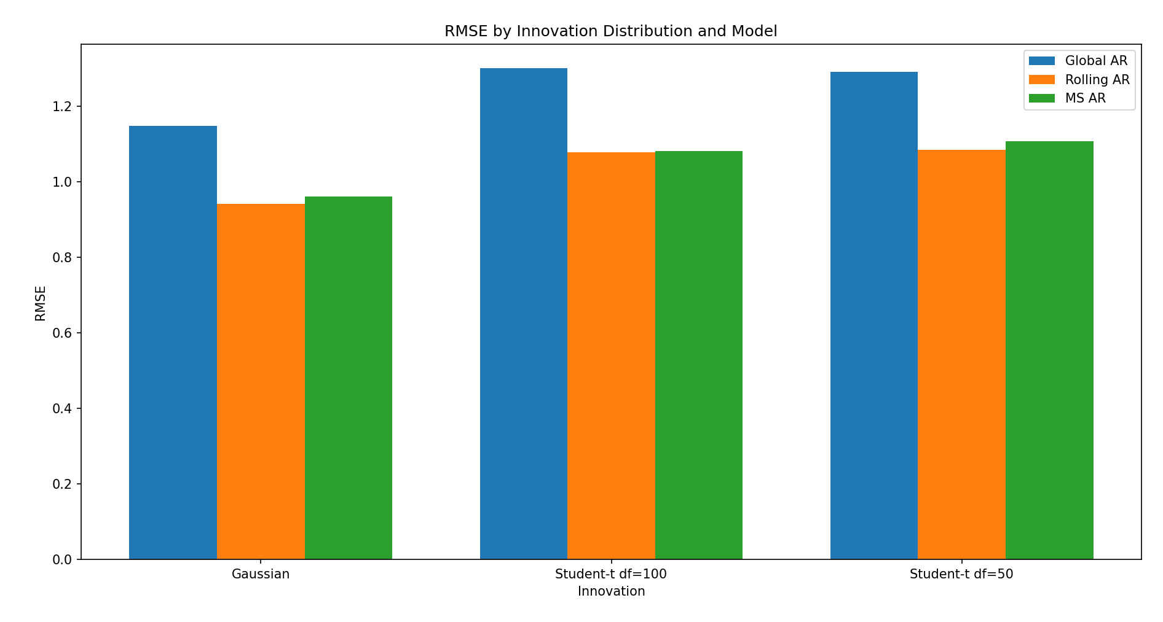
Rolling AR and Markov-switching AR models consistently outperform the Global AR benchmark, indicating that adaptive estimation mitigates the effects of parameter instability. Under Gaussian innovations, Rolling AR delivers the lowest RMSE, while the Markov-switching model performs comparably but does not dominate. As tail thickness increases (df = 100 and df = 50), RMSE differences between Rolling AR and Markov-switching AR narrow, suggesting that both models respond similarly to mild departures from Gaussianity. Overall, the relative ranking of models remains stable across innovation distributions, implying that improvements in forecast accuracy are driven primarily by structural adaptation rather than by assumptions on the innovation distribution.

Forecast Error Distributions under Alternative Innovation Distributions (Single Break).
The figure reports one-step-ahead forecast error distributions following a single deterministic parameter break under Gaussian and mildly heavy-tailed Student-t innovations (df = 100 and df = 50). Across all innovation distributions, forecast errors are centered close to zero, indicating the absence of economically meaningful systematic bias. Departures from Gaussianity primarily affect the dispersion and tail behavior of forecast errors rather than their central location. As the degree of tail thickness increases, error distributions widen and exhibit greater mass in the extremes, reflecting higher forecast uncertainty induced by larger shocks.
Bias varies modestly across innovation distributions. Under Gaussian innovations, forecast errors exhibit a small negative bias, consistent with attenuation in post-break persistence estimates caused by averaging across pre- and post-break regimes. Introducing mildly heavy-tailed innovations (df = 100) reduces this attenuation effect and shifts bias closer to zero by increasing the effective weight of recent observations. With heavier tails (df = 50), occasional large shocks inflate estimated persistence, leading to slight overprediction and positive bias. These bias shifts remain quantitatively small relative to overall forecast dispersion and do not alter qualitative model comparisons.
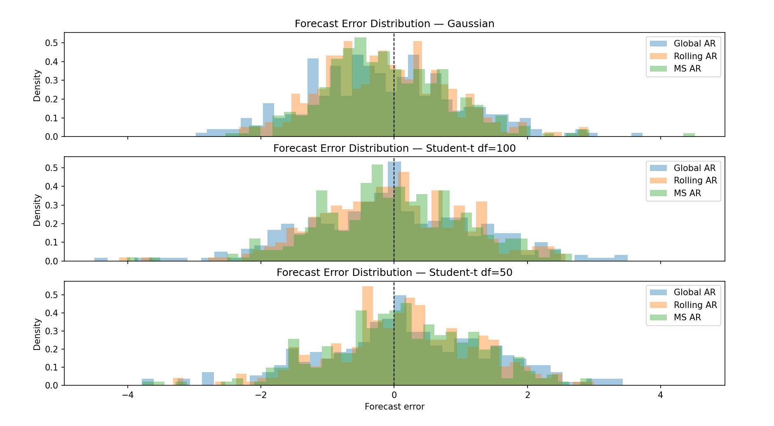
Importantly, the relative ordering of forecasting models is robust across innovation distributions. Rolling and Markov-switching AR models display modest reductions in forecast dispersion relative to the Global AR benchmark, while differences across models remain limited. This indicates that predictive instability following structural breaks is driven primarily by parameter changes rather than by the distributional form of the innovations. Overall, the results demonstrate that comparative forecasting performance under structural breaks is robust to realistic, finite-variance departures from Gaussianity, with innovation tail behavior affecting uncertainty but not the fundamental conclusions.
Experiments with substantially heavier-tailed innovations (df = 10) were also conducted but are not reported, as extreme shocks dominated forecast error measures and obscured the role of structural instability, shifting the analysis toward outlier sensitivity rather than parameter change.

Recurring Breaks:

Interpretation of RMSE across regime persistence levels (Gaussian)
The figure reports one-step-ahead forecast RMSE for Global AR, Rolling AR, and Markov-switching AR models under varying degrees of regime persistence.
When regime persistence is low ($p=0.90$), forecast performance is nearly identical across models. In this environment, regimes switch frequently, rendering regime inference unreliable. As a result, the additional structure of the Markov-switching model does not translate into forecast gains, while adaptive rolling and global estimators perform similarly.
As persistence increases to moderate levels ($p=0.95$), differences across models remain small. Although regimes last longer, they are still insufficiently persistent for regime probabilities to become strongly informative, limiting the advantage of structural modeling.
At higher persistence ($p=0.97$), clear performance differences emerge. The Markov-switching model begins to outperform both the rolling and global benchmarks, reflecting improved regime identification and reduced parameter uncertainty. In contrast, the global AR model deteriorates as long regime spells amplify the cost of averaging across structurally distinct dynamics.
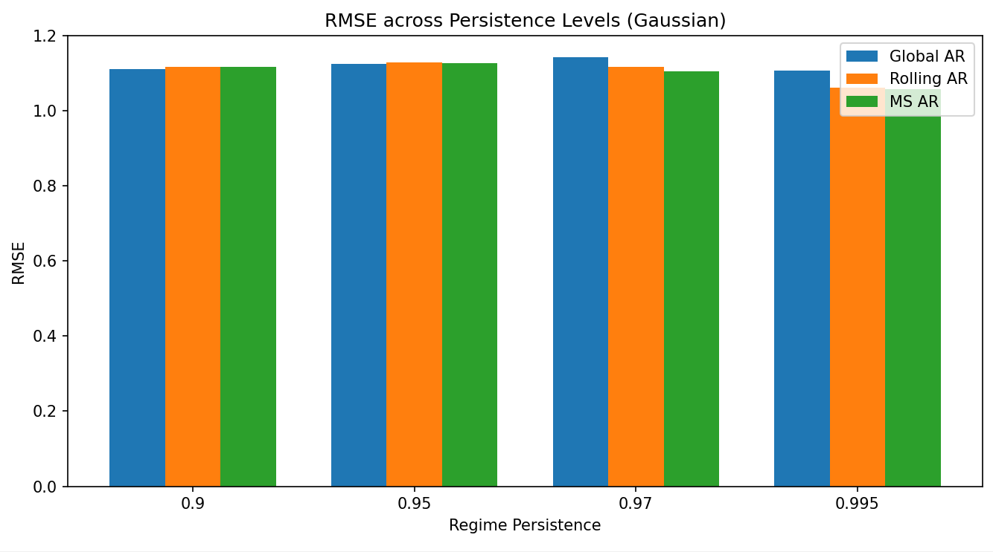
In the near-permanent regime case ($p=0.995$), the Markov-switching model achieves the lowest RMSE. Here, the data-generating process closely matches the model’s structure, allowing it to exploit regime information effectively. Rolling AR improves relative to lower persistence levels but remains dominated by the Markov-switching model, while the global AR model performs worst due to persistent misspecification.
Overall, the figure shows that increasing regime persistence does not universally improve forecast accuracy. Instead, forecast gains accrue only to models capable of exploiting regime structure. Structural models benefit from persistence, whereas mis specified global estimators may experience worsening performance as regime differences become more pronounced.

Interpretation of MAE across regime persistence levels (Gaussian)
The figure reports mean absolute forecast errors (MAE) for Global AR, Rolling AR, and Markov-switching AR models across increasing levels of regime persistence.
At low persistence ($p=0.90$), MAE differences across models are small. Frequent regime switching prevents reliable regime inference, so the structural advantage of the Markov-switching model does not translate into lower absolute errors. All models exhibit comparable average forecast deviations.
As persistence increases to $p=0.95$, MAE rises slightly for all models, reflecting longer regime spells that begin to penalize misspecification. However, performance differences remain limited, as regimes are still not persistent enough for regime probabilities to be sharply identified.
At higher persistence ($p=0.97$), the Markov-switching model achieves the lowest MAE, followed by the rolling estimator, while the global AR model performs worst. This indicates that persistent regimes allow the Markov-switching model to reduce systematic forecast deviations by conditioning on regime-specific dynamics. In contrast, the global AR model suffers from sustained bias due to averaging across distinct regimes.
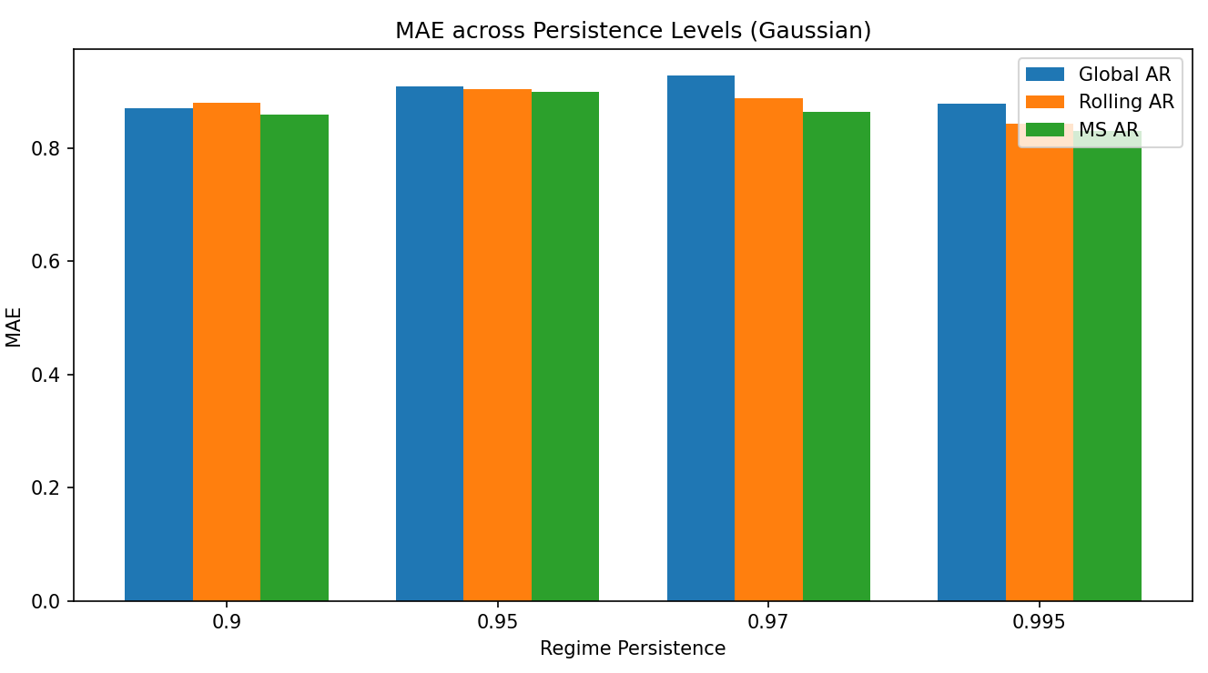
In the near-permanent regime case ($p=0.995$), the Markov-switching model maintains the lowest MAE. Rolling AR improves relative to lower persistence levels but remains dominated by the Markov-switching specification. The global AR model exhibits the largest average absolute errors, consistent with persistent structural misspecification.
Overall, the MAE results reinforce the RMSE findings: increasing regime persistence does not uniformly reduce forecast errors. Instead, gains accrue to models capable of exploiting regime structure. Structural models reduce average absolute forecast deviations as persistence increases, while misspecified global models remain biased and do not benefit from higher persistence.

Key takeaway
MAE evidence confirms that regime persistence benefits structural models by reducing systematic forecast errors, while adaptive and global benchmarks fail to exploit persistent regime information.

Forecast Bias across Regime Persistence (Gaussian).
The figure reports average one-step-ahead forecast bias for Global AR, Rolling AR, and Markov-switching AR models under increasing regime persistence. Bias magnitudes are small across all models, indicating that forecast errors are primarily driven by variance rather than systematic misprediction. At low persistence ($p=0.90$), bias differences are negligible due to frequent regime switching that limits reliable regime identification.
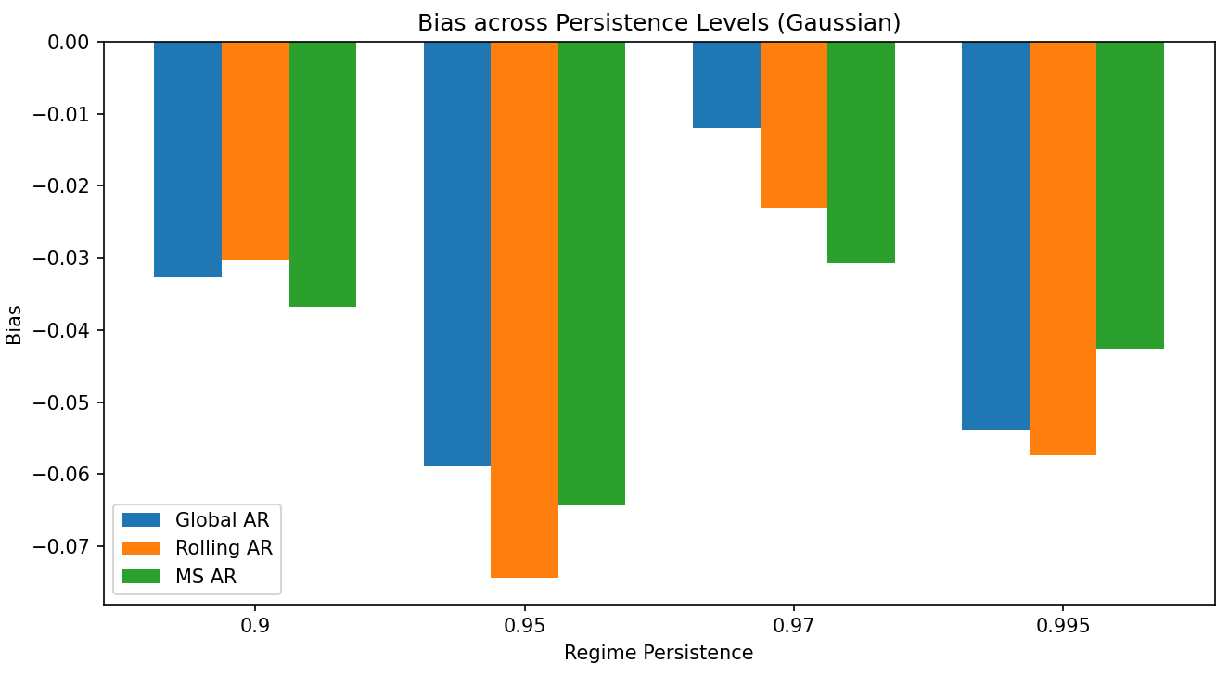
As persistence increases, the Global AR model exhibits increasingly negative bias, consistent with persistent misspecification from averaging across distinct regimes. Rolling AR bias varies non-monotonically, reflecting sensitivity to window composition and regime mixing. In contrast, the Markov-switching model attains the lowest absolute bias at higher persistence levels ($p≥0.97$), reflecting improved regime identification when regimes are sufficiently persistent.

Data-Generating Process under Recurring Parameter Instability.
The figure illustrates realizations of a Markov-switching AR(1) process for increasing levels of regime persistence. Shaded regions indicate the high-persistence regime ($ϕ_{1}$), while unshaded regions correspond to the low-persistence regime ($ϕ_{0}$). When persistence is low ($p=0.90$), regimes switch frequently, producing many short regime spells.
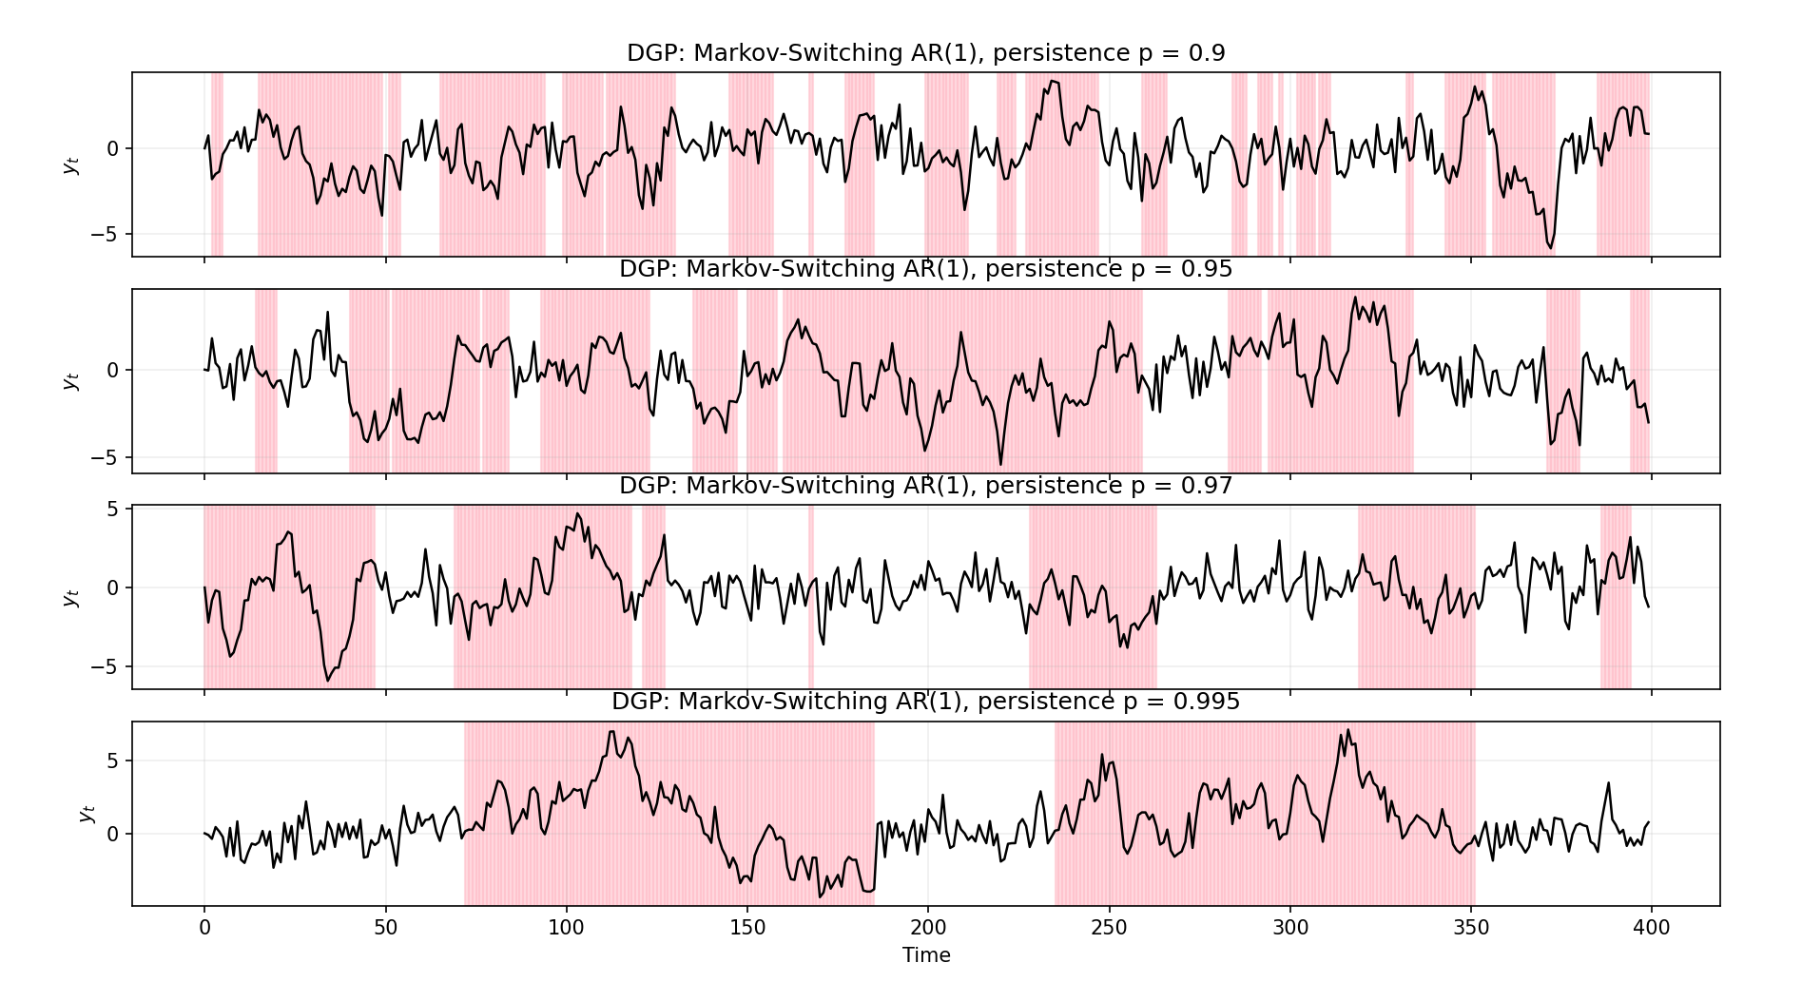
As persistence increases ($p=0.95$ and $p=0.97$), regime durations lengthen and the series exhibits extended periods of distinct dynamics. In the high-persistence case ($p=0.995$), regime switches are rare and regime spells become long but remain stochastic, illustrating near-permanent yet non-degenerate parameter regimes.

Forecast Error Distributions under Recurring Parameter Instability (Gaussian).
The figure shows that forecast error distributions narrow as regime persistence increases, reflecting a more stable forecasting environment. When persistence is low ($p=0.90$), frequent regime switches prevent reliable regime identification, leading to wide and highly overlapping error distributions across all models. As persistence rises ($p≥0.97$), error distributions become more concentrated around zero, and the Markov-switching AR model exhibits slightly reduced dispersion and thinner tails relative to Global and Rolling AR estimators.
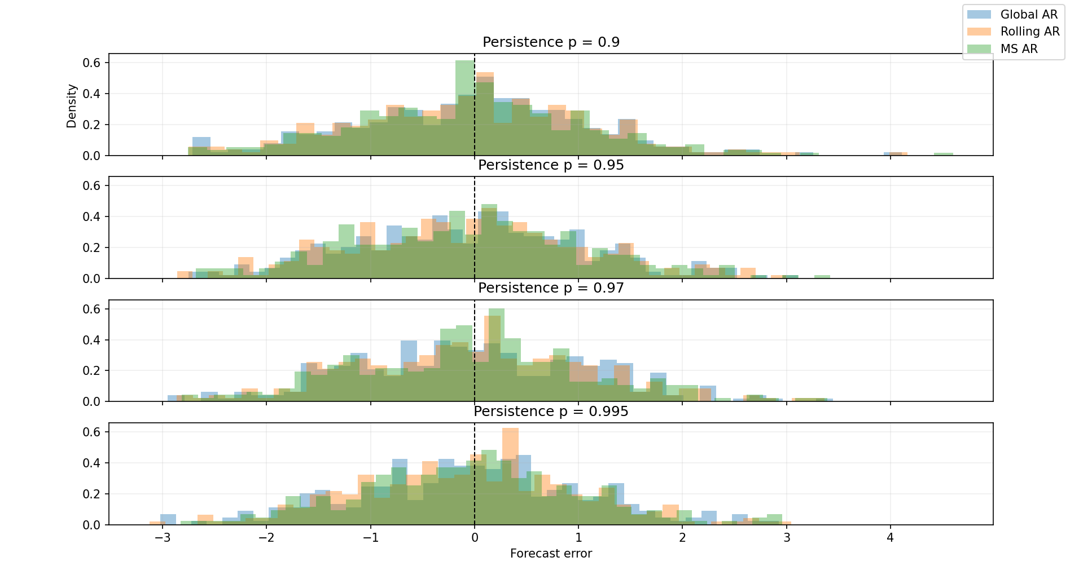
These gains are modest and primarily distributional rather than mean-based, indicating that regime-switching models improve forecast precision by reducing variance rather than eliminating bias.

Key takeaway
As regime persistence increases, forecast error distributions become more concentrated, and the Markov-switching model exhibits modest reductions in dispersion relative to fixed-parameter and rolling estimators, reflecting improved exploitation of persistent regime dynamics.

